Rotor speed wm(rad/s)

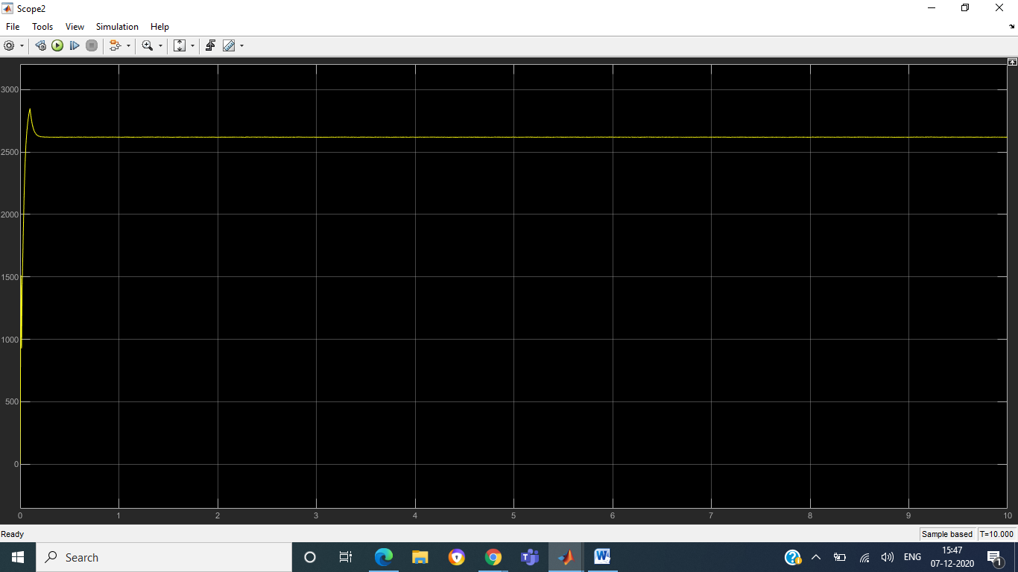

Electromagnetic Torque Te(N*m)

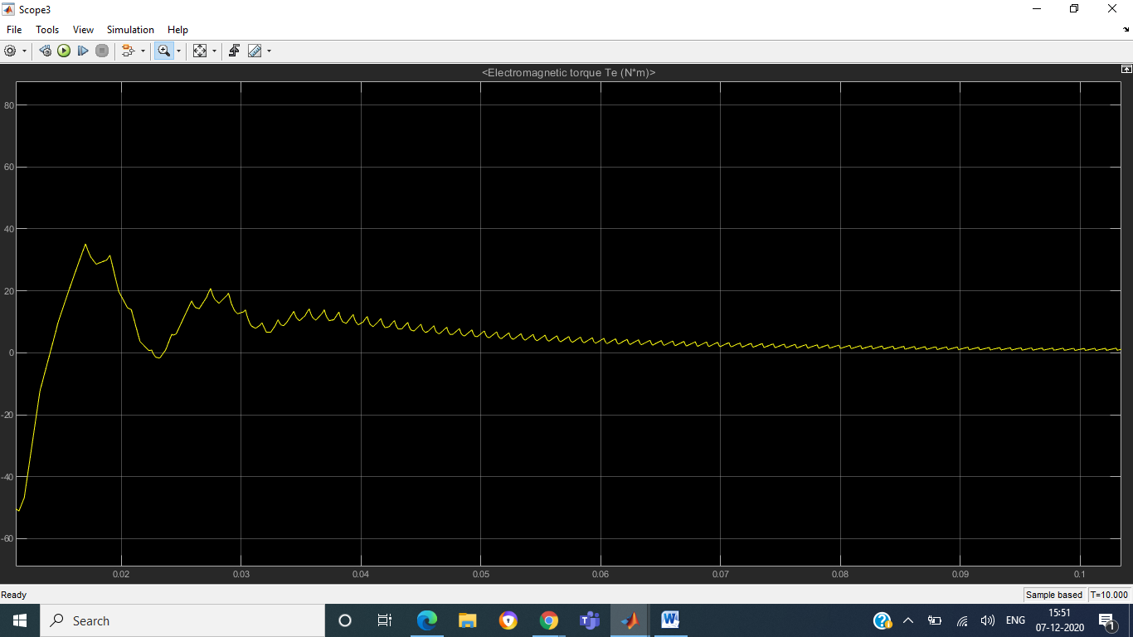

Stator current a and Stator back EMF e_a

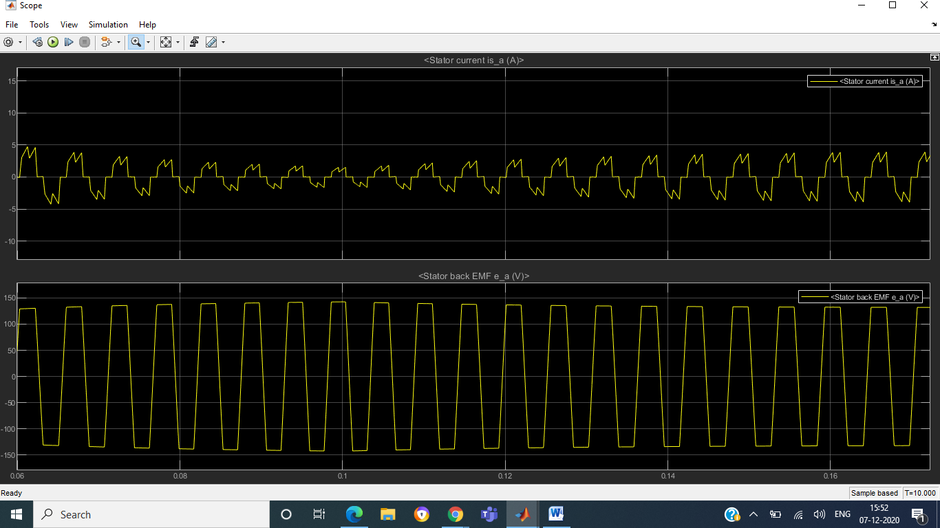

Stator current b and Stator back EMF e_b

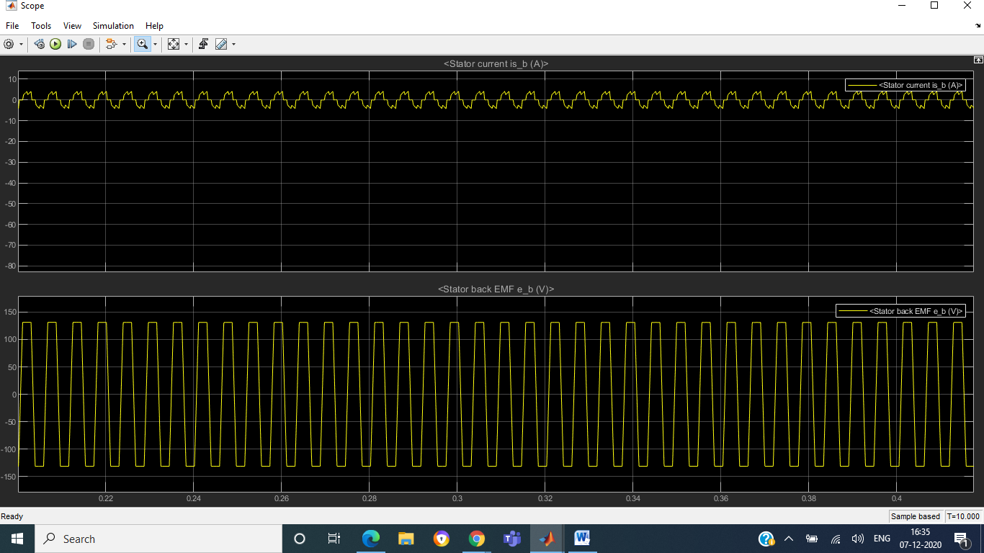

Stator current c and Stator back EMF e_c

